**Pizza Sales SQL Queries**

1. **KPI’s**
2. **Total Revenue:**

SELECT SUM(total_price) as Total_Revenue FROM pizza_sales

**Output:**



1. **Average Order Value:**

SELECT SUM(total_price) / COUNT(DISTINCT order_id) as Avg_Order_Value FROM pizza_sales

**Output:**



1. **Total Pizza Sold:**

SELECT SUM(quantity) as Total_Pizza_Sold FROM pizza_sales

**Output:**



1. **Total Orders:**

SELECT COUNT(DISTINCT order_id) as Total_Orders from pizza_sales



1. **Average Pizzas Per Order**

SELECT

CAST (CAST(SUM(quantity) as decimal(10,2) )

/ CAST(COUNT(DISTINCT order_id) as decimal(10,2)) as decimal(10,2)) as Avg_Pizza_Sold_Per_Order FROM pizza_sales



1. **Charts Requrement**
2. **Daily Trend for Total Orders:**

SELECT

DATENAME(DW,order_date) as Order_day,

COUNT(DISTINCT order_id) as Total_Orders

FROM pizza_sales

GROUP BY DATENAME(DW,order_date)

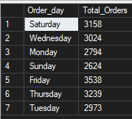

1. **Monthly Trend for Total Orders:**

SELECT * from pizza_sales

SELECT

DATENAME(MONTH,order_date) as Month_Name,

COUNT(DISTINCT order_id) as Total_Orders

FROM pizza_sales

GROUP BY DATENAME(MONTH,order_date)

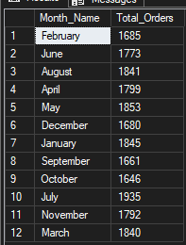

1. **Percentage of Sales by Pizza Category:**

SELECT pizza_category, SUM(total_price) AS Total_Sales,

SUM(total_price)*100/

(SELECT sum(total_price) FROM pizza_sales) AS PCT

FROM pizza_sales GROUP BY pizza_category

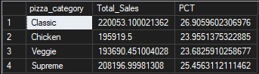

1. **Percentage of Sales by Pizza Category:**

SELECT pizza_size, SUM(total_price) AS Total_Sales,

SUM(total_price)*100/

(SELECT sum(total_price) FROM pizza_sales) AS PCT

FROM pizza_sales

GROUP BY pizza_size

ORDER BY PCT DESC

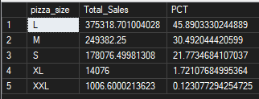

1. **Top/Bottom 5 Best Sellers by Revenue. Total Quantity and Total Orders:**

**By Revenue:**

SELECT TOP 5 pizza_name, SUM(total_price) as Revenue FROM pizza_sales

GROUP BY pizza_name ORDER BY Revenue DESC

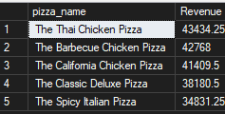

**For Bottom 5:**

SELECT TOP 5 pizza_name, SUM(total_price) as Revenue FROM pizza_sales

GROUP BY pizza_name ORDER BY Revenue ASC

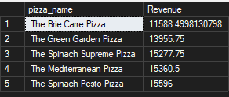

**By Quantity:**

SELECT TOP 5 pizza_name, SUM(quantity) as Total_Quantity FROM pizza_sales

GROUP BY pizza_name ORDER BY Total_Quantity DESC

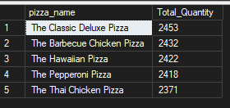

Bottom 5:

SELECT TOP 5 pizza_name, SUM(quantity) as Total_Quantity FROM pizza_sales

GROUP BY pizza_name

ORDER BY Total_Quantity ASC

